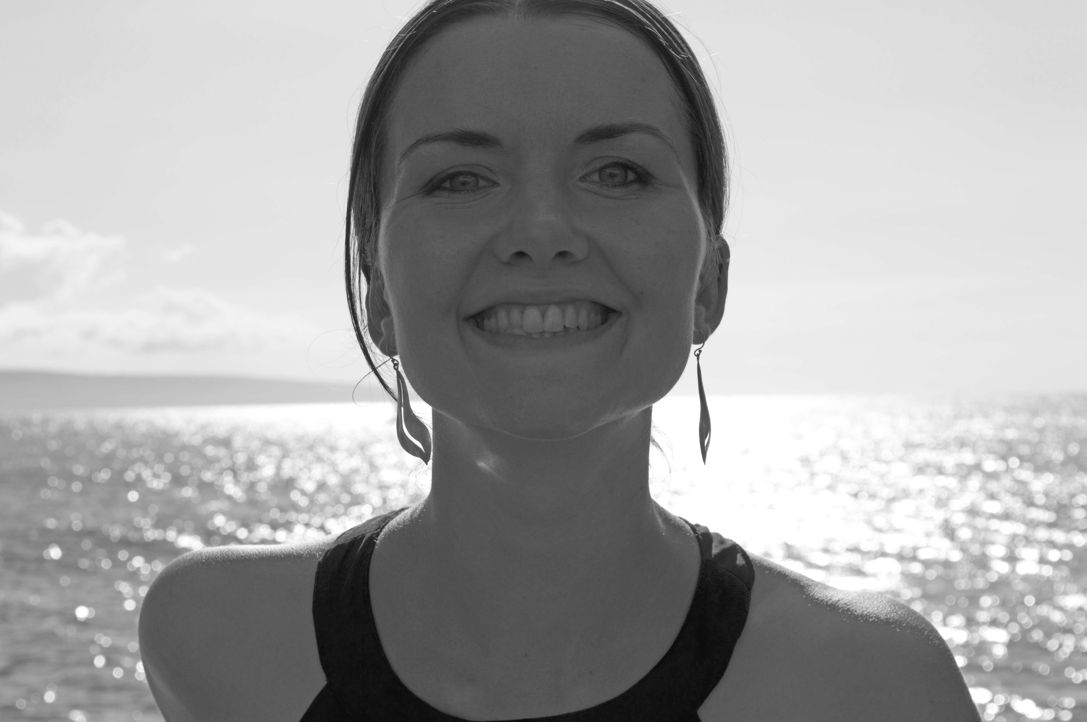

Thank you so much for your interest in a Making Money Feels Like Bliss Consultation!
Please take a few minutes to fill out this application, so that we can explore your business dreams. When you’re finished, simply email this questionnaire back to us at Support@AvaWaits.com before the end of Sunday, June 7th. We’ll be in touch shortly to let you know if you’ve received one of the 6 available consultations that Ava has open right now.

Your Name:
Email:
Website:
Phone Number:
Your Time Zone:
Mailing Address:

1. Please share a little bit about your business, as well as your business plans and intentions for the rest of 2015. What you share will be kept completely confidential.

2. In what ways does making money not feel like bliss right now?

3. What do you feel needs to change so that you can have a happier experience making money?

4. What kinds of mentorship and guidance have you previously purchased for your business?

5. Ava has digital programs and private coaching packages to fit a variety of levels, and the current investment for these ranges from $480 to $20,000. If you and Ava determine that she can support you after the Making Money Feels Like Bliss consultation, are you ready and able to invest in yourself?

6. Why do you feel that Ava would be the right mentor for you on this part of your entrepreneurial journey?

“One little Ava-ism completely re-framed a negative belief I had in my business and also gave me a record breaking $2323 day. Before speaking to Ava, I had the belief that going on holidays in my business meant complete poverty and no clients when I came back. Ava said one little sentence – ‘Traveling is my best marketing campaign’ – and it clicked. The day after I came back from 2 weeks in Hawaii, I had a record breaking $2323 day and I was ‘in the flow’ for the next 2 completely booked out weeks.”
- Tammy Guest, Naturopath www.inspirationalhealth.com.au

“Hi Ava, I want to share my excitement about money that showed up for me after making an initial private coaching payment to work with you. The payment was made in faith that money would return to me and fill what space had opened up. Within one week of making this payment, a client signed up for long term work with me and paid in full. The payment was $1640!”
- Naomi www.truly-u.com Truly-U, Facebook

